LECTURE No. 5

CUSTOMER RELATIONSHIP MANAGEMENT (CRM)

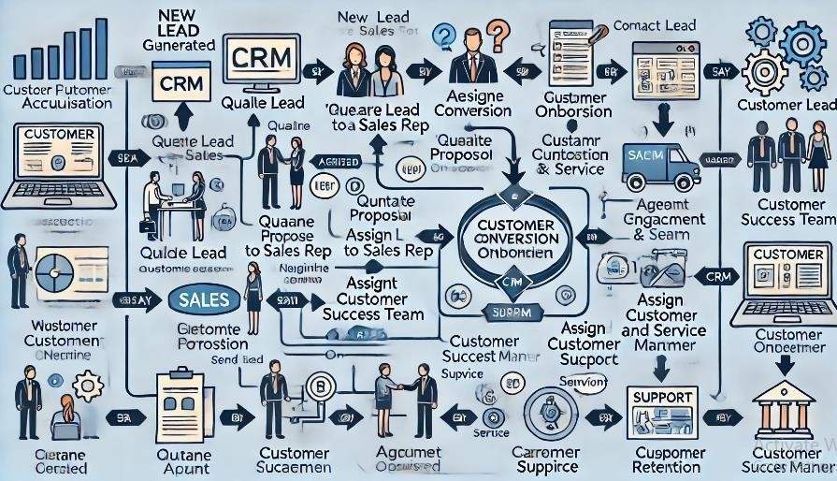
List of Topic to be Discuss in this Lecture

- Introduction to CRM
- Key Components of CRM
- CRM Process Stages
- CRM Technology and Software
- Benefits of Implementing CRM
- Challenges in CRM Implementation
- CRM Trends
- Measuring CRM Success
- CRM Best Practices
- Business Process Modeling of CRM

Introduction to CRM

  - Definition: Customer Relationship Management (CRM) is a strategic approach to managing interactions with current and potential customers. It uses data analysis about customers' history with the company to improve business relationships, primarily focusing on customer retention and driving sales growth.

Importance of CRM:
    - Helps build and maintain strong customer relationships.
    - Improves customer satisfaction and loyalty.
    - Supports data-driven decision-making.
    - Increases efficiency in customer interactions and enhances sales processes.

Key Components of CRM

Operational CRM
  - Focuses on automating customer-facing processes like sales, marketing, and customer service.
  - Features: Sales force automation (SFA), marketing automation, and service automation.
  - Goal: Streamline processes, improve communication, and increase productivity in customer-facing teams.

Analytical CRM
  - Analyzes customer data for strategic insights.
  - Features: Data mining, predictive analytics, and reporting tools.
  - Goal: Understand customer behavior, preferences, and trends to make informed business decisions.

Collaborative CRM
  - Focuses on improving collaboration between teams and with customers.
  - Features: Shared customer data, communication tools, and project management.
  - Goal: Improve the quality of customer interactions and ensure consistency across all touchpoints.

CRM Process Stages

Customer Acquisition
    - Attracting new customers through targeted marketing campaigns, lead generation, and conversion strategies.
    - Techniques: Social media, email marketing, and content marketing.

Customer Engagement
    - Building and maintaining relationships with existing customers.
    - Techniques: Regular follow-ups, personalized communication, and quality customer support.

Customer Retention
    - Retaining existing customers by ensuring satisfaction and providing additional value.
    - Techniques: Loyalty programs, personalized offers, and consistent engagement.

Customer Loyalty and Advocacy
    - Turning satisfied customers into brand advocates who promote the company through word-of-mouth.
    - Techniques: Referral programs, reviews and testimonials, and exceptional service experiences.

CRM Technology and Software

- CRM Software: Tools that facilitate CRM processes by collecting, managing, and analyzing customer data. Examples include Salesforce, HubSpot, Zoho CRM, and Microsoft Dynamics.

Key Features:
  - Contact Management: Organizes and tracks customer information.
  - Sales Management: Manages sales activities, pipeline, and opportunities.
  - Marketing Automation: Streamlines marketing tasks like email campaigns, lead scoring, and segmentation.
  - Customer Service Management: Tracks customer service requests, interactions, and feedback.
  - Analytics and Reporting: Provides insights into customer behavior, sales performance, and other KPIs.

Benefits of Implementing CRM
- Enhanced Customer Satisfaction: Personalized communication and efficient service improve customer experience.
- Increased Sales: CRM helps identify and prioritize sales opportunities, leading to higher conversion rates.
- Improved Customer Retention: By tracking and analyzing customer behavior, businesses can proactively address needs and retain customers.
- Efficient Marketing: Segmentation and targeted marketing reduce costs and improve ROI.
- Data-Driven Decision-Making: CRM systems provide valuable insights for better business decisions.

Challenges in CRM Implementation

- Data Management: CRM requires accurate, up-to-date customer data, which can be challenging to collect and maintain.
- User Adoption: CRM systems are only effective if employees actively use and update them.

- Integration with Existing Systems: CRM should integrate seamlessly with other software to provide a comprehensive view of customer interactions.
- Cost and ROI: CRM implementation can be costly, and the return on investment (ROI) may take time to realize.

CRM Trends

  - AI and Automation: AI-powered CRM tools provide automated recommendations, predictive analytics, and chatbots for 24/7 customer support.
  - Omnichannel CRM: Integrated channels (social media, email, phone, live chat) provide a seamless customer experience.
  - Mobile CRM: Mobile-optimized CRM solutions allow sales and customer service teams to work effectively on the go.
  - Customer Data Privacy: With increased regulations (like GDPR), CRM systems are prioritizing data security and privacy features.

Measuring CRM Success
- Customer Lifetime Value (CLV): Measures the total revenue a customer will generate over the lifetime of their relationship with the company.
- Customer Retention Rate: Tracks the percentage of customers retained over a period.
- Customer Satisfaction Score (CSAT): Direct feedback from customers to measure satisfaction.
- Net Promoter Score (NPS): Measures customer loyalty and likelihood of referrals.
- Sales Growth: Tracks increases in sales and revenue, attributing success to CRM effectiveness.

CRM Best Practices

- Focus on Customer Needs: Ensure CRM processes and strategies are customer-centric.
- Train Employees: Proper training is crucial to maximize CRM adoption and effectiveness.
- Clean and Maintain Data: Regularly update and clean customer data for accuracy.
- Personalize Interactions: Use CRM insights to tailor communications and offers.
- Monitor Performance: Regularly review CRM metrics to identify areas for improvement.

Business Process Modeling of CRM

Customer Acquisition

  - Start Event: New lead generated

Activities:
    - Qualify Lead: Determine if the lead is a potential customer.
    - Assign Lead to Sales Rep: Based on lead qualification, assign to the appropriate salesperson.

    - Contact Lead: Sales rep contacts the lead through calls, emails, or meetings.
    - Follow-Up: Regular follow-up activities to move the lead along the sales funnel.
  - Gateway: Lead interested? (Yes/No)
  - End Event: If “No,” lead is lost.

Customer Conversion

  - Start Event: Lead shows interest.

Activities:
    - Prepare Proposal: Sales rep prepares a customized proposal or offer.
    - Send Proposal to Lead: Proposal is shared with the lead for review.
    - Negotiate Terms: Any necessary negotiation on pricing or terms.
  - Gateway: Agreement achieved? (Yes/No)
  - End Event: If “No,” lead is lost.

Customer Onboarding

  - Start Event: Agreement signed.

Activities:
    - Set Up Customer Account: CRM account is created with customer details.
    - Welcome and Onboarding: Customer receives welcome materials and onboarding support.
    - Assign Customer Success Manager (CSM): CSM is assigned to manage ongoing customer relations.
  - End Event: Customer onboarding complete.

Customer Engagement and Service

  - Start Event: Customer onboarding complete.

Activities:
    - Provide Customer Support: CSM or support team assists with customer inquiries.
    - Upsell/Cross-Sell: CSM identifies opportunities for additional products or services.
    - Collect Customer Feedback: Routine feedback collection through surveys or touchpoints.
  - End Event: Continuous support provided.

Customer Retention

  - Start Event: Customer engagement phase.

Activities:
    - Renewal Process: Initiate renewal process for recurring customers.
    - Offer Loyalty Programs: Offer loyalty rewards or discounts to encourage retention.
    - Address Churn Risks: Identify and address any potential reasons for customer churn.

  - End Event: Retention achieved (Yes/No).

This BPMN workflow in the CRM process would involve tasks managed by the sales, customer success, and support teams, each represented by their own swimlanes in a BPMN diagram. The diagram flow helps visualize the end-to-end customer journey, from lead generation to customer retention.

CRM Strategy for a Retail Business

  - Operational CRM: Automates sales, marketing, and customer service to enhance efficiency. Examples include:

    - Sales Force Automation (SFA) to track purchases and leads.
    - Marketing Automation for personalized offers and loyalty reminders.
    - Customer Service Automation like chatbots for 24/7 support.

  - Analytical CRM: Uses data to identify patterns and improve strategies, such as:

    - Predicting at-risk customers and offering retention deals.
    - Analyzing sales data to understand customer preferences and trends.
    - Generating reports to assess engagement effectiveness.

  - Collaborative CRM: Improves teamwork and customer communication by:

    - Sharing customer data across teams for consistent interactions.
    - Using dashboards to track loyalty program participation.
    - Collecting feedback via surveys to refine strategies.

Outcome: A seamless, data-driven approach that boosts engagement, satisfaction, and loyalty.

